*Laboratory Report*

**INTERNET TECHNOLOGIES LAB.**

**CAP5004L**

**School of Engineering**

**Department of Computer Science and Engineering**

|  |  |
| --- | --- |
| **Submitted By** | |
| **Student Name** | Amit |
| **Roll Number** | 180020307001 |
| **Section/Group** |  |
| **Department** | Computer Science and Engineering |
| **Session/Semester** | 2020-21/ Odd Semester |
| **Submitted To** | |
| **Faculty Name** | Ms. Manka Sharma |



**GD Goenka University**

Sohna road, Gurugram, Haryana

**Table of Content**

|  |  |  |  |
| --- | --- | --- | --- |
| Sl No | Date | Aim of the Experiment | Signature/date |
|  |  |  |  |
|  |  |  |  |
|  |  |  |  |
|  |  |  |  |
|  |  |  |  |
|  |  |  |  |
|  |  |  |  |
|  |  |  |  |
|  |  |  |  |
|  |  |  |  |

|  |  |  |
| --- | --- | --- |
| **Experiment No-9.1** |  | **Date:** |

**Aim of the Experiment:**

Write a program in JavaScript to search a string within another string.

**Source Code**

<!DOCTYPE html>

<html lang="en">

<head>

<meta charset="UTF-8">

<meta name="viewport" content="width=device-width, initial-scale=1.0">

<title>Document</title>

</head>

<body>

<script>

var string = "Hello World";

var search = string.search('Hello');

document.write(search);

</script>

</body>

</html>

**Output**

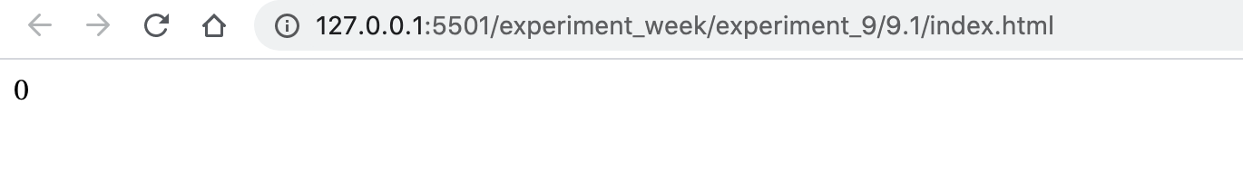

|  |  |  |
| --- | --- | --- |
| **Experiment No-9.2** |  | **Date:** |

**Aim of the Experiment:**

Write a program in JavaScript to search multiple occurrences of a string within a string.

**Source Code**

<!DOCTYPE html>

<html lang="en">

<head>

<meta charset="UTF-8">

<meta name="viewport" content="width=device-width, initial-scale=1.0">

<title>Document</title>

</head>

<body>

<script>

var string = "Hello World, Hello ma'am, Hello Computer";

var search = string.match(/Hello/g);

document.write(search);

</script>

</body>

</html>

**Output**

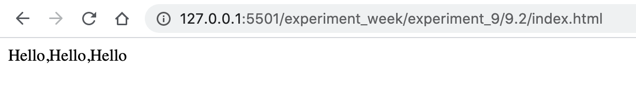

|  |  |  |
| --- | --- | --- |
| **Experiment No-9.3** |  | **Date:** |

**Aim of the Experiment:**

Write a program to perform the following on string(s):

a. Concatenation

b. Conversion to upper and lower case

c. Sort the letters within a string

d. Search, replace and match within a string

e. Test and Exec in a string

**Source Code**

<!DOCTYPE html>

<html lang="en">

<head>

<meta charset="UTF-8">

<meta name="viewport" content="width=device-width, initial-scale=1.0">

<title>Document</title>

</head>

<body>

<div id="concat">Concat:- </div>

<div id="lower">Lower:- </div>

<div id="upper">Upper:- </div>

<div id="sort">Sort:- </div>

<div id="search">Search:- </div>

<div id="replace">replace:- </div>

<div id="match">match:- </div>

<div id="test">test:- </div>

<div id="exec">exec:- </div>

<script>

var str1 = "Amit";

var str2 = "Dagar";

// CONCATENATION

document.getElementById('concat').innerText += str1 + str2;

// LOWER

document.getElementById('lower').innerText += (str1 + str2).toLowerCase();

// UPPER

document.getElementById('upper').innerText += (str1 + str2).toUpperCase();

// sort

document.getElementById('sort').innerText += (str1 + str2).toLowerCase().split('').sort().join('');

// SEARCH

document.getElementById('search').innerText += (str1 + str2).search('Amit');

// REPLACE

document.getElementById('replace').innerText += (str1 + str2).replace('Amit', 'Hello Amit ');

// MATCH

document.getElementById('match').innerText += (str1 + str2).match(/Amit/g);

// TEST

var reg = new RegExp('a');

document.getElementById('test').innerText += reg.test(str1 + str2);

// EXEC

document.getElementById('exec').innerText += reg.exec(str1 + str2);

</script>

</body>

</html>

**Output**

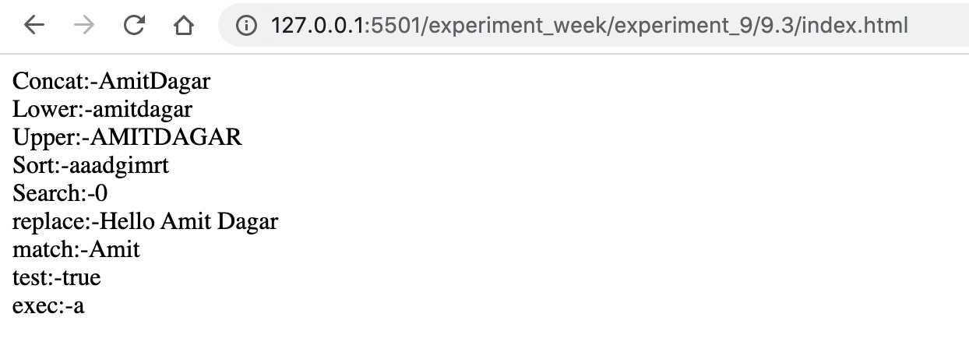

|  |  |  |
| --- | --- | --- |
| **Experiment No-9.4** |  | **Date:** |

**Aim of the Experiment:**

Write a JavaScript function that accepts a list of country names as input and returns the longest country name as output.

**Source Code**

<!DOCTYPE html>

<html lang="en">

<head>

<meta charset="UTF-8">

<meta name="viewport" content="width=device-width, initial-scale=1.0">

<title>Document</title>

</head>

<body>

<script>

longest_country_name = (coutries) => {

var max_length = 0, length = 0, country = '';

for(var i = 0; i < coutries.length; i++) {

length = coutries[i].split('').length;

if(max_length < length){

max_length = length, country = coutries[i];

}

}

return(country);

}

const countryList = [

"Afghanistan",

"Albania",

"Algeria",

"American Samoa",

"Andorra",

"Angola",

"Anguilla",

"Antarctica",

"Antigua and Barbuda",

"Argentina",

"Armenia",

"Aruba",

"Australia",

"Austria",

"Azerbaijan",

"Bahamas (the)",

"Bahrain",

"Bangladesh",

"Barbados",

"Belarus",

"Belgium",

"Belize",

"Benin",

"Bermuda",

"Bhutan",

"Bolivia (Plurinational State of)",

"Bonaire, Sint Eustatius and Saba",

"Bosnia and Herzegovina",

"Botswana",

"Bouvet Island",

"Brazil",

"British Indian Ocean Territory (the)",

"Brunei Darussalam",

"Bulgaria",

"Burkina Faso",

"Burundi",

"Cabo Verde",

"Cambodia",

"Cameroon",

"Canada",

"Cayman Islands (the)",

"Central African Republic (the)",

"Chad",

"Chile",

"China",

"Christmas Island",

"Cocos (Keeling) Islands (the)",

"Colombia",

"Comoros (the)",

"Congo (the Democratic Republic of the)",

"Congo (the)",

"Cook Islands (the)",

"Costa Rica",

"Croatia",

"Cuba",

"Curaçao",

"Cyprus",

"Czechia",

"Côte d'Ivoire",

"Denmark",

"Djibouti",

"Dominica",

"Dominican Republic (the)",

"Ecuador",

"Egypt",

"El Salvador",

"Equatorial Guinea",

"Eritrea",

"Estonia",

"Eswatini",

"Ethiopia",

"Falkland Islands (the) [Malvinas]",

"Faroe Islands (the)",

"Fiji",

"Finland",

"France",

"French Guiana",

"French Polynesia",

"French Southern Territories (the)",

"Gabon",

"Gambia (the)",

"Georgia",

"Germany",

"Ghana",

"Gibraltar",

"Greece",

"Greenland",

"Grenada",

"Guadeloupe",

"Guam",

"Guatemala",

"Guernsey",

"Guinea",

"Guinea-Bissau",

"Guyana",

"Haiti",

"Heard Island and McDonald Islands",

"Holy See (the)",

"Honduras",

"Hong Kong",

"Hungary",

"Iceland",

"India",

"Indonesia",

"Iran (Islamic Republic of)",

"Iraq",

"Ireland",

"Isle of Man",

"Israel",

"Italy",

"Jamaica",

"Japan",

"Jersey",

"Jordan",

"Kazakhstan",

"Kenya",

"Kiribati",

"Korea (the Democratic People's Republic of)",

"Korea (the Republic of)",

"Kuwait",

"Kyrgyzstan",

"Lao People's Democratic Republic (the)",

"Latvia",

"Lebanon",

"Lesotho",

"Liberia",

"Libya",

"Liechtenstein",

"Lithuania",

"Luxembourg",

"Macao",

"Madagascar",

"Malawi",

"Malaysia",

"Maldives",

"Mali",

"Malta",

"Marshall Islands (the)",

"Martinique",

"Mauritania",

"Mauritius",

"Mayotte",

"Mexico",

"Micronesia (Federated States of)",

"Moldova (the Republic of)",

"Monaco",

"Mongolia",

"Montenegro",

"Montserrat",

"Morocco",

"Mozambique",

"Myanmar",

"Namibia",

"Nauru",

"Nepal",

"Netherlands (the)",

"New Caledonia",

"New Zealand",

"Nicaragua",

"Niger (the)",

"Nigeria",

"Niue",

"Norfolk Island",

"Northern Mariana Islands (the)",

"Norway",

"Oman",

"Pakistan",

"Palau",

"Palestine, State of",

"Panama",

"Papua New Guinea",

"Paraguay",

"Peru",

"Philippines (the)",

"Pitcairn",

"Poland",

"Portugal",

"Puerto Rico",

"Qatar",

"Republic of North Macedonia",

"Romania",

"Russian Federation (the)",

"Rwanda",

"Réunion",

"Saint Barthélemy",

"Saint Helena, Ascension and Tristan da Cunha",

"Saint Kitts and Nevis",

"Saint Lucia",

"Saint Martin (French part)",

"Saint Pierre and Miquelon",

"Saint Vincent and the Grenadines",

"Samoa",

"San Marino",

"Sao Tome and Principe",

"Saudi Arabia",

"Senegal",

"Serbia",

"Seychelles",

"Sierra Leone",

"Singapore",

"Sint Maarten (Dutch part)",

"Slovakia",

"Slovenia",

"Solomon Islands",

"Somalia",

"South Africa",

"South Georgia and the South Sandwich Islands",

"South Sudan",

"Spain",

"Sri Lanka",

"Sudan (the)",

"Suriname",

"Svalbard and Jan Mayen",

"Sweden",

"Switzerland",

"Syrian Arab Republic",

"Taiwan",

"Tajikistan",

"Tanzania, United Republic of",

"Thailand",

"Timor-Leste",

"Togo",

"Tokelau",

"Tonga",

"Trinidad and Tobago",

"Tunisia",

"Turkey",

"Turkmenistan",

"Turks and Caicos Islands (the)",

"Tuvalu",

"Uganda",

"Ukraine",

"United Arab Emirates (the)",

"United Kingdom of Great Britain and Northern Ireland (the)",

"United States Minor Outlying Islands (the)",

"United States of America (the)",

"Uruguay",

"Uzbekistan",

"Vanuatu",

"Venezuela (Bolivarian Republic of)",

"Viet Nam",

"Virgin Islands (British)",

"Virgin Islands (U.S.)",

"Wallis and Futuna",

"Western Sahara",

"Yemen",

"Zambia",

"Zimbabwe",

"Åland Islands"

];

var country = longest_country_name(countryList);

document.write(`Country ${country} with length ${country.split('').length}`);

</script>

</body>

</html>

**Output**



|  |  |  |
| --- | --- | --- |
| **Experiment No-9.5** |  | **Date:** |

**Aim of the Experiment:**

Write a JavaScript function which accepts an argument and returns the type.

**Source Code**

<!DOCTYPE html>

<html lang="en">

<head>

<meta charset="UTF-8">

<meta name="viewport" content="width=device-width, initial-scale=1.0">

<title>Document</title>

</head>

<body>

<script>

args_type = (arg) => {

return typeof arg;

}

document.write(args_type(12));

</script>

</body>

</html>

**Output**

